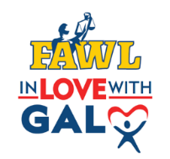
Mentor Information
Date: _________
Name: _________________________________________
Phone: _________________________________________
Email: _________________________________________
Preferred Location (County): _______________________

The FAWL in Love with GAL Program matches older youth in foster care with FAWL members. The FAWL members will provide mentoring and support to the youth and will work with the GAL team to ensure the youth’s needs are met.
Youth will be over the age of 13 and post TPR with no adoptive family currently identified.
To assist with creating the most effective mentor-mentee match, please fill out the short questionnaire below.
Mentor Questionnaire
- Please list any prior experience with mentoring or working with youth.

- Are there type of cases or issues you would prefer not be involved with?

- Do you have any personal experiences or feelings that could affect the mentee relationship?

- When is the best time normally for you to meet with your mentee?

- Are you willing to travel to meet with your mentee? If so, how far?

- What is your goal for this mentoring opportunity?

- Any other relevant information.

To Be Completed by GAL Program Statewide Pro Bono Liaison

Circuit ___________________

Case Assigned ___________________

Date Assigned _____________________

